Support Vector machine

**Dataset Selection:**

**Data set Description described Below  
“Business Context**

**Pharmaceutical companies invest millions of dollars in clinical trials to test drug efficacy. However, some drugs do not work for all patients due to individual differences in biology, metabolism, and pre-existing conditions.**

**Traditional clinical trials take years to conclude, with high costs and risks.**

**Machine learning models can help predict drug response early, saving time and resources.**

**Personalized medicine ensures that patients receive the right drug at the right dose.**

**-------------------------------------------------------------------------------------------------------------------------------**

**Drug Response Classification (0 = No response, 1 = Positive response)**

Drug response classification refers to how a patient’s body **reacts to a particular drug**. This is a key concept in **pharmaceutical research** and **clinical trials**, where researchers analyze whether a drug is **effective or not** based on biological responses.

**Interpretation of Classification Labels:**

1. **0 = No Response**
   * The drug **did not have a significant effect** on the patient.
   * The patient’s condition **remained unchanged** after taking the drug.
   * The biomarkers (e.g., blood pressure, glucose level, heart rate) **did not improve**.
   * Possible reasons:
     + The drug is not suitable for the patient.
     + The dosage is ineffective.
     + The patient's metabolism is resistant to the drug.
2. **1 = Positive Response**
   * The drug **had a beneficial effect** on the patient.
   * The patient’s condition **improved after taking the drug**.
   * Biomarkers such as blood pressure, glucose levels, and enzyme activity **show significant improvement**.
   * Possible reasons:
     + The drug is effective for this patient.
     + The dosage is appropriate.
     + The patient’s metabolism responds well to the drug.

**Why is This Classification Important?**

* **Pharmaceutical Industry:** Used to test new drugs and evaluate their effectiveness before FDA approval.
* **Personalized Medicine:** Helps doctors prescribe drugs based on individual patient responses.
* **Machine Learning in Healthcare:** Enables predictive models to **forecast patient responses** based on medical data.

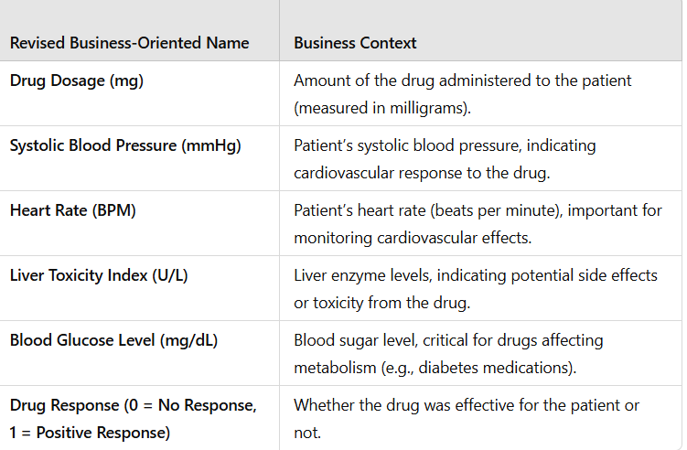

**”**

**Task 1: Exploratory Data Analysis (EDA)**

1. Load the dataset and perform fundamental data exploration.
2. Utilize histograms, box plots, or density plots to understand feature distributions.
3. Investigate feature correlations to discern relationships within the data.

**Task 2: Data Preprocessing**

1. Encode categorical variables if necessary.
2. Split the dataset into training and testing sets.

**Task 3: Data Visualization**

1. Employ scatter plots, pair plots, or relevant visualizations to comprehend feature distributions and relationships.
2. Visualize class distributions to gauge dataset balance or imbalance.

**Task 4: SVM Implementation**

1. Implement a basic SVM classifier using Python libraries like scikit-learn.
2. Train the SVM model on the training data.
3. Evaluate model performance on the testing data using appropriate metrics (e.g., accuracy, precision, recall, F1-score).

**Task 5: Visualization of SVM Results**

1. Visualize classification results on the testing data.

**Task 6: Parameter Tuning and Optimization**

1. Experiment with different SVM hyperparameters (e.g., kernel type, regularization parameter) to optimize performance.

**Task 7: Comparison and Analysis**

1. Compare SVM performance with various kernels (e.g., linear, polynomial, radial basis function).
2. Analyze SVM strengths and weaknesses for the dataset based on EDA and visualization results.
3. Discuss practical implications of SVM in real-world classification tasks.

I have attached one Mega coding problem statement. Write Python solutions for each in a short, simple, and human-like style, similar to how a student or beginner would code naturally.

The code should look original, not AI-generated — use natural variable names, compact logic, and clear structure. Avoid unnecessary comments, over-optimization, or advanced syntax.

Make sure every solution covers all requirements of the problem statement, but still stays clean, minimal, and easy to follow.

Each problem’s code should be written in its own cell or section, one after another, as if written in a Jupyter Notebook.

Keep the tone and coding pattern consistent with human-written notebooks take more time but give me best answer suitable for about details.